NATIVE ALIEN (New York Version May 2012)

for solo musician and immersive comprovisation environment

Based on a lipogram poem using only nine-letters "INSIDE A NATIVE LAND", this performance enacts an improvisational letter-for-letter reading: each letter stands for an emotional state (Rasa), a spatial behaviour and a specific improvisational language, that both the performer and the computer musician must execute. The letters INSDEATVL are arranged in a nine-dot matrix, with the I of the performer at the center, while the other letters represent one specific behaviour of the OMAX improviser.

|  |  |  |
| --- | --- | --- |
| T | E | N |
| D | I | S |
| V | A | L |

NATIVE ALIEN emerges as a comprovisation between this conceptual composition, embodied by an interactive score, and the interplay of situational real-time composition by humans and machines.

Native Alien is a **matra**lab research-creation project, and was generously funded with a major grant by the FQRSC (Quebec Fund for Research in Science and Culture). Over the past 3 years, various leading musicians from diverse traditions have worked with and contributed to research on this project, among them: Mike Svoboda (Trombone, Switzerland), Amelia Cuni (Dhrupad, Vicenza), Vinny Golia (Saxes/Flutes, Los Angeles), Rohan de Saram (Cello, London), Wu Wei (Sheng, Berlin), Dhruba Ghosh (Sarangi, Mumbai), Coat Cooke (Sax, Vancouver), Mei Han (Guzheng, Vancouver), Cheryl L'Hirondelle (Cree Recitation, Vancouver), Lori Freedman (Montréal), David Rosenboom (Piano, Los Angeles).

**Native Alien Team:**

Composer, Concept : Sandeep Bhagwati

Performer (New York): Lori Freedman

Computer Musician: Navid Navab

Interactive Score: Julian Stein

Project Website:

<http://matralab.hexagram.ca/projects/?title=NativeAlien>

I

i live:

inside

a vineland,

an eden, divine,

alive in its tiniest detail

II

still i insist:

it is a land in leaden denial

all tilted, all stained, all enslaved

its senile daddies stall all vital ideals

sell stale ideas instead and devise listless steals.

III

it is all i detest :

devil’s land

its natives ease all atavist needs

vile teens taste tanned tits, eat svelte slits

idle ladies in veils sin at tea in venitian tents

IV

still avid I leave:

in lent, leaves still lean,

i set sails - and leave at late tide.

V

i see, i listen, i invent

VI

i see:

valiant sea-tested vessels dive

slain alive in intense evil

and dead seas distended in vast vistas

VII

i invent tall tales at nite

visit alien lands as a saint visits sins

VIII

and as i stand

livid in salient dissent

still at sea,

invalid and nestless

IX

i listen, i listen,

a sentient island,

insane and insatiate

still, silent, alive,

**inside - a native land**

**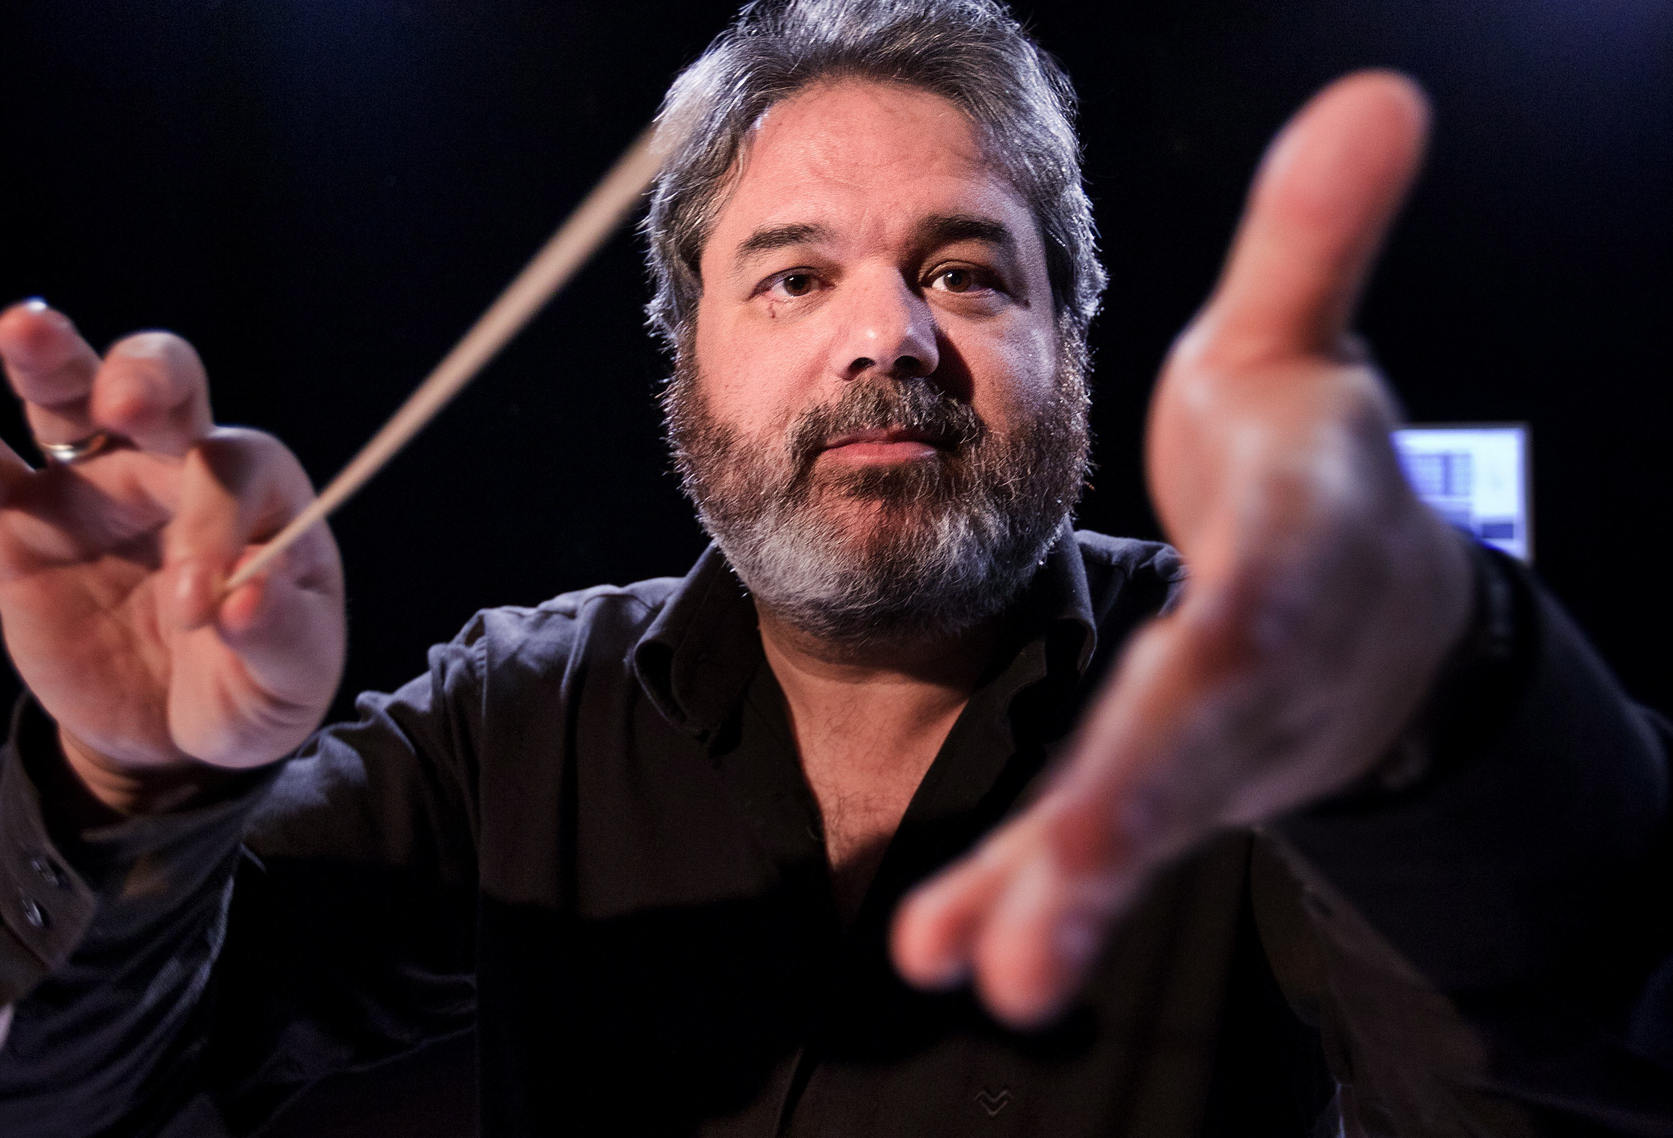Sandeep Bhagwati** is a multiple award-winning composer, theatre director and media artist. He studied at Mozarteum Salzburg (Austria), Institut de Coordination Acoustique/Musique IRCAM Paris (France) and graduated with a Diplom in Composition from Hochschule für Musik und Theater München (Germany) His compositions and comprovisations in all genres (including 6 operas) have been performed by leading performers at leading venues and festivals worldwide. He has directed international music festivals and intercultural exchange projects with Indian and Chinese musicians and leading new music ensembles. He was a Professor of Composition at Karlsruhe Music University, and Composer-in-Residence at the IRCAM Paris, ZKM Center for Arts and Media Karlsruhe, Beethoven Orchestra Bonn, Institute for Electronic Music Graz, CalArts Los Angeles, Heidelberg University and Tchaikovsky Conservatory Moscow. He also was a guest professor at Heidelberg University in 2009.

As Canada Research Chair for Inter-X Arts at Concordia University Montréal since 2006 he currently directs **matra**lab, a research/creation center for intercultural and interdisciplinary arts. His current work centers on comprovisation, inter-traditional aesthetics, the aesthetics of interdisciplinarity, gestural theatre, sonic theatre and interactive visual and non-visual scores. From 2008 to 2011, he also was the director of Hexagram Concordia, a centre for research-creation in media arts with a faculty of 45 artist-researchers and extensive state-of-the-art facilities.

**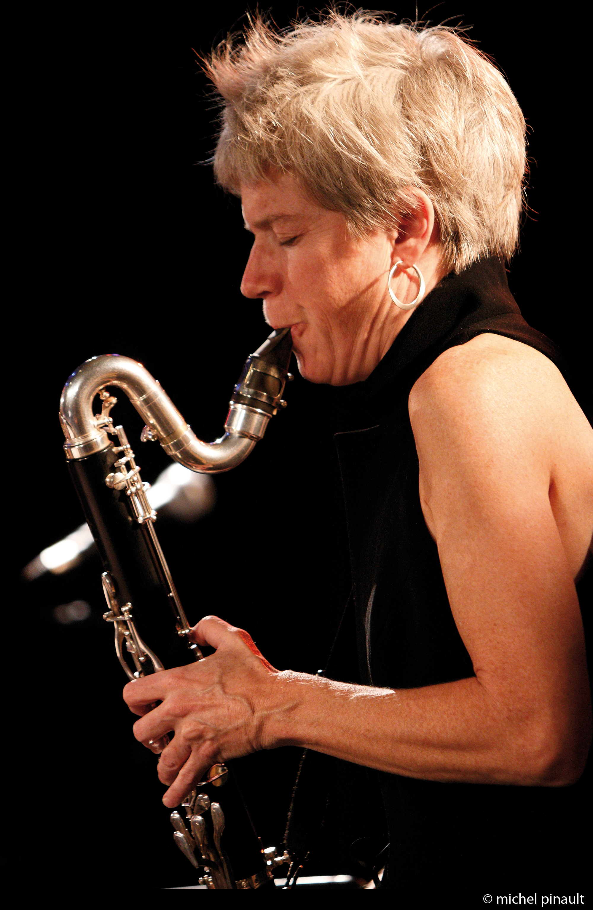Lori Freedman** is known internationally as one of the most provocative and creative performers in the field of contemporary music. Her work includes concert repertoire, improvised and electroacoustic music, and she frequently collaborates with dance, theatre and visual artists. Over 45 composers have written solo bass clarinet music for her, and since 1981 Freedman has been working with an eclectic mix of musicians including Toru Takemitsu, Iva Bittova, Helmut Lachenmann, Joélle Léandre, Rajesh Mehta Mauricio Kagel, Steve Lacy, George Lewis, Iannis Xenakis, Frances Marie Uitti, Misha Mengleberg, Evan Parker, Mark Dresser, Suzie Ibarra, Fred Frith, Giorgio Magnanensi, Ab Baars, Joe McPhee, Barry Guy, John Oswald, Benny Sluchin, Karl-Heinz Essl, Sandeep Bhagwati, Ana Sokolović, Bernard Falaise, Martin Tétreault, Jean Derome, René Lussier, Rohan de Saram and Diane Labrosse. Her work has been recorded on 28 CDs. In 1998 Lori Freedman received the prestigious Freddie Stone Award for the “demonstration of outstanding leadership, integrity and excellence in the area of contemporary music and jazz” and at the National Jazz Awards she was nominated as Clarinetist of the Year in 2003, ’04, and ’06.

**Navid Navab** is a Montreal based ‘media-alkemist,’ composer, performer, programmer, and sound designer. Currently an artist and researcher at Topological Media Lab, **matra**lab, and Alkemie Atelier, he studied Electroacoustics and Computational Arts at Concordia University as well as Music Technology at McGill University. Navab has collaborated with various groups and artists including Jean Derome, Bozzini Quartet, Blue Rider Ensemble, Constantinople Ensemble, Vinny Golia, Pierre Tanguay, Coat Cooke, Zata Omm Dance Project, Sinha Danse, Alexander Wang, Xin Wei Sha, Michael Montanaro and Sandeep Bhagwati.

Navid uses gestures, rhythms and vibrations from everyday life as basis for sound generation, resulting in augmented acoustical-poetry. His investigations, which range from compositions to responsive architecture, interface design, theatral interactive installations, and improv-based performances, have been presented at various festivals and events in many countries. Some venues include ChampLibre Montreal, Canadian Center for Architecture, Festival du Nouveau Cinema, Electric Eclectics Festival Meaford, Roulet Mixoiology Festival New York, Western Front Vancouver, StudentFest Romania, CCRMA California, CMS Black Box Cambridge UK, Box13 Houston, La Société des Arts Technologiques [SAT], les Territoires Gallery Montreal, Agora Montreal, E-arts China, Fashion Night Out [FNO] New York, and l’envers Montreal.

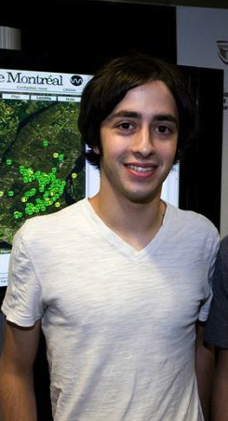

**Julian Stein** is a composer and sound enthusiast currently residing and studying in Montréal. His interests lie primarily in musical applications of phonetics, bioacoustics, synchronization, and the urban environment. He is a founding member of the Concordia Electroacoustic Studies Student Association (CESSA) and co-creator of the [Montreal Sound Map](http://montrealsoundmap.com/" \t "_blank), an interactive Google Maps-based archive of Montreal's soundscape. He currently is a research assistant at **matra**lab (Concordia University).